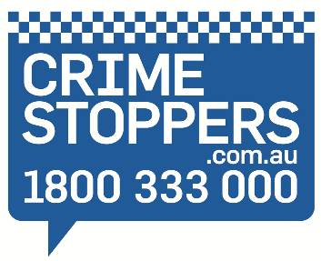

Mooloolaba

CRIME STOPPERS BOWLS DAY

**FRIDAY 15 OCTOBER 2021**

**REGISTRATION:** **11:00 am**

**TEAM BRIEFING: 11:30 pm**

**START OF BOWLING: 12:00 NOON**

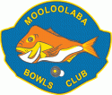**Mooloolaba Bowls Club**

**Brisbane Road**

**Mooloolaba**

**Teams of 4 - 6: $40.00 per person**

**Day includes: Bowls-Undercover (4 hours)**

**BBQ lunch**

**Drinks – Your choice of 4 drinks**

**Great Day, Great Prizes, Fancy Dress Encouraged**

**Come and have fun while supporting your local Crime Stoppers Committee.**

**BOOK YOUR TEAM NOW before 10 OCTOBER 2021**

**Direct Credit Payment to Crime Stoppers Qld Ltd**

**Bendigo Bank, (BSB)633-000 Acc 175665371 ref SUN3501(YOUR SURNAME).**

**CONTACT: S/Const Jeff FRAZER at Maroochydore 0488 777979**

**or email your team registrations to: Frazer.JeffreyR@police.qld.gov.au**

**Crime Stoppers and Mooloolaba Bowls Club support the responsible consumption of Alcohol**

**FULL COVID SAFE AND SOCIAL DISTANCING RESTRICTIONS WILL BE ADHERED TO.**

Mooloolaba

CRIME STOPPERS BOWLS DAY

**Mooloolaba Bowls Club**

**Brisbane Road**

**Mooloolaba**

**REGISTRATION FORM**

**Yes, I would like to enter a team**

**Team Name:**

**Team Members:**

**Contact Person:**

**Email address:**

**Contact No:**

**OFFICE USE ONLY**

**Payment Rec’d:**  **Yes**  **No**

**Amount Rec’d:**

**Receipt No:**